Nepal College of Information Technology
Assessment
Fall 2011
Program : BE-ELX Time : 3 hrs
Semester : Fall (I) FM : 100
Subject : Basic Electrical Engineering PM : 50

- Candidates are requested to give their answer as far as practicable in their own words.
- The figure in the margin indicates the full marks
- Attempt ALL question

1. a) Using Nodal analysis, find the current in the 5Ω resistor in the figure below: [7]
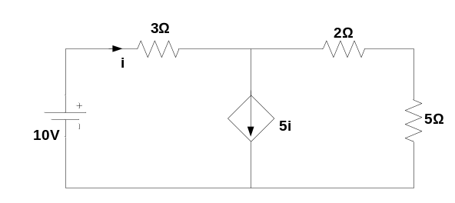
b) Using the super-position theorem, calculate the magnitude and direction of the current through resistor 3Ω in the circuit shown. [8]
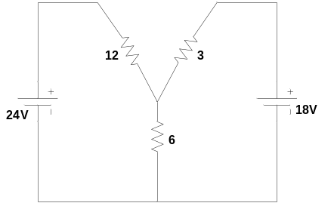
2. a) What do you mean by ideal and non-ideal sources? State maximum power transfer theorem and hence derive the condition for maximum power transfer. [7]

b) Utilizing Thevenin’s theorem, calculate the current flowing through 10Ω resistor in the circuit shown below. [8]
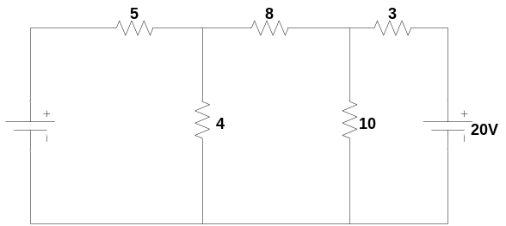

3. a) Determine the average and RMS value of the following waveform. [7]
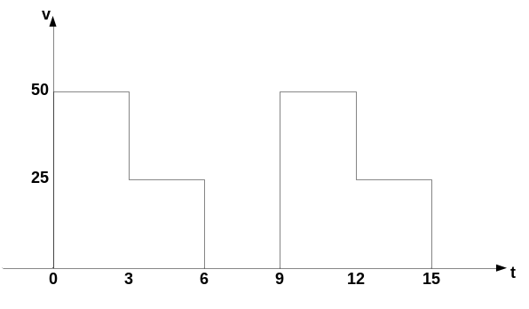
b) A coil having a resistance of 10Ω and inductance of 0.2H is connected in series with a capacitor 59.7µF. The circuit is connected across a 100V, 50Hz ac supply. Calculate the current flowing, the voltage across capacitor, voltage across inductor and power factor.[8]

4. a) Explain two wattmeter method of three phase power measurement. [7]
b) A 400 V balanced Y-connected supply is connected to three equal impedances (80+j60) Ω in delta (∆)-formation. Calculate phase current, line current, power factor and power consumed. [8]
5. a) Describe the working principle of single phase transformer. What are the losses occurred in transformer? [7]
b) Following data were obtained from the test of a 30 KVA, 3000/110 V and 50 Hz single phase transformer.
O.C. test: 110V 10.2A 350W on L.V. side
S.C. test: 150V 10A 500W on H.V. side
Calculate draw the equivalent circuit of transformer referred to Secondary side. [8]

6. a) Explain the construction of DC machine. [7]
b) A 240V DC shunt motor takes 25A at rated voltage and runs at 1000 rpm. Its field resistance is 120Ω and armature circuit resistance is 0.3Ω. Compute the value of additional resistance required in the armature circuit to reduce the speed to 900 rpm, when the load torque is independent of speed. [8]

7. Write short notes on any two of the following: [5X2=10]
a) Dependent and Independent Sources
b) Resonance in RLC series
c) Efficiency of transformer.

